Ideological Motives: White Man’s Burden
After the United States acquired the Philippines Islands in the wake of the Spanish-America War. Author Rudyard Kipling wrote the poem, The White Man’s Burden to the American people about assuming colonial control of the islands. After reading The White Man Burden, you will answer the following questions in a few sentences:
- What exactly is the burden?

- Why is it a burden (why does Kipling call it a burden instead of “duty” “privilege,” or a “right”)?

- What is the tone of the poem? Is it cheerful, somber, disappointment, satire or was it something else?

- According to Kipling, who suffers more, the empire or the colony?

- How well does the cartoon below, capture the meaning of the poem? Cite specific features of the cartoon as well as specific images and passages from the poem.

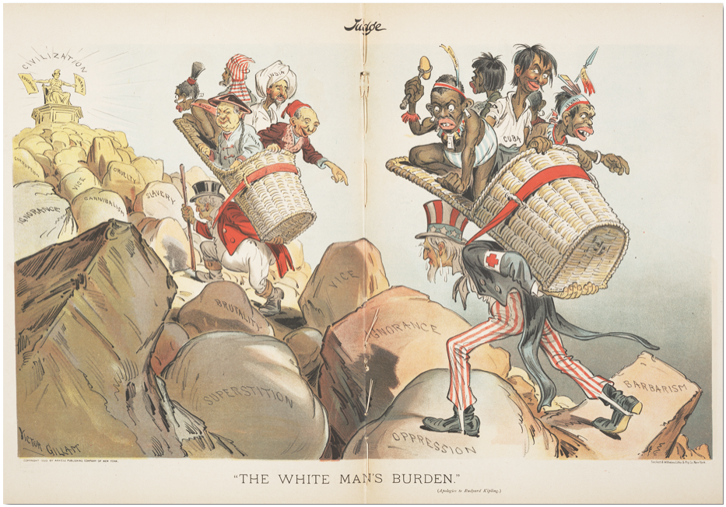
Stones read (from right to left): Barbarism, oppression, ignorance, vice, superstition, brutality, slavery, cruelty, cannibalism, vice, ignorance [again], superstition [again]. Statue reads: “Civilization”, holding signs for “liberty” and “Civilization”

Cecil Rhodes, on African Imperialism:
“I contend that we [Britons] are the finest race in the world, and the more of the world we inhabit, the better it is for the human race. . . . It is our duty to seize every opportunity of acquiring more territory and we should keep this one idea steadily before our eyes that more territory simply means more of the Anglo-Saxon race, more of the best, the most human, most honourable race the world possesses.”
- What attitude about the British does Rhodes statement display?

- How might a native African react to this statement? Explain

- Why and how did racism grow as imperialism grew?

Use the cartoon of Cecil Rhodes below and use the picture to answer the following questions:
- How is Cecil Rhodes dressed? What items is he carrying?

- What is he standing on? Can you make out what countries or areas he has on his feet?

- Based on this picture, how do you think Cecil Rhodes viewed the continent of Africa? Why?

- Rhodes was once quoted as saying, “I would annex the planet if I could”, what do you think he meant by this?
