The Scramble for Africa- 5/6
Use your notes from yesterday and the maps below to answer the following questions
- Before the 1800s, how much land in Africa did Europeans control? (%)

- How did the Industrial Revolution affect the Scramble for Africa?

- What is the Scramble for Africa?

- Which European Leader organized the Berlin Conference? And what country is he from?

- Why did European countries gather for the Berlin Conference?

- What were the outcomes from the Berlin Conference?

- Why do you think the European powers wanted to leave the Congo and Niger River Basins “neutral?”

- Which European leader, personally claimed the Congo Free State as his own?

- How did the Ethiopians defend their land from the Italians?

*Use Maps Below
- Which European country had the most colonies in Africa by 1914? How many did they have?

- Which European country had the least number of colonies in Africa by 1914? How many did they have?

- Which two colonies remained independent even after the scramble for Africa?

- How did imperialism in Africa in 1850 compare with that in 1914?

- How might the carving up of Africa like a cake by the Europeans have negatively impacted the native people living there?
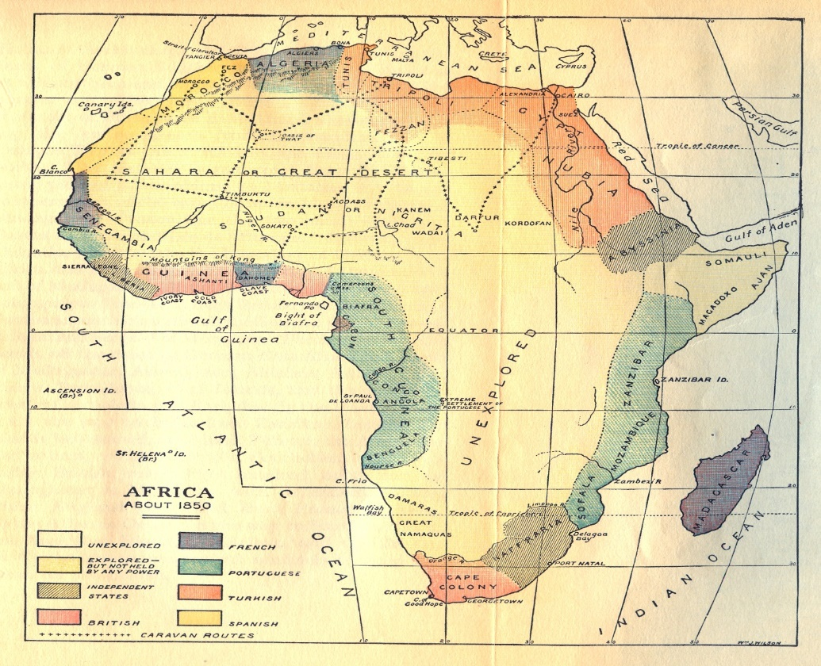
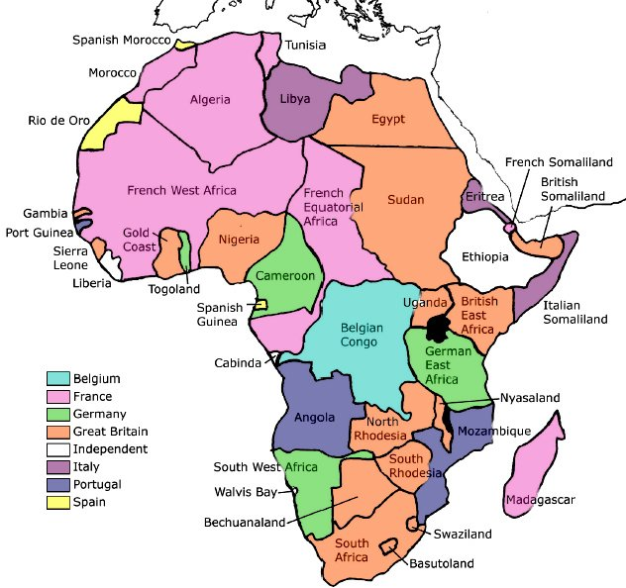
Map of 1914 Africa
Map of 1850 Africa

