Abbasid Caliphate Trade Map Name:
The Abbasid Caliphate was the center of something called the Silk Road. Below, you will map the Abbasid Caliphate, the trade routes, and the trade goods from each region. Use Mr Best’s Website for resources. Start by labelling the following regions: Abbasid Caliphate, China, India, Byzantium, Central Asia, Europe, Indonesia, Sub-Saharn Africa.
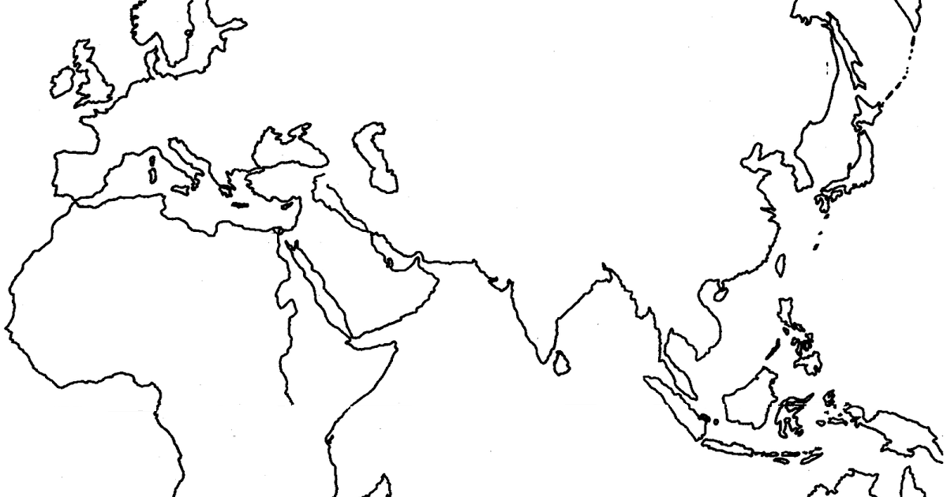
Legend (draw simple picture for each)
Horses | Books | Gunpowder | Ivory | Timber | Camels
Metal | Silk | Medicine | Fruit | Skins/Furs | Slaves
Incense | Porcelain | Cotton | Wine | Mercenary soldiers | Almonds
Slaves | Paper | Spices | Glass | Dogs | Olives
Furs | Grapes | Gold

Abbasid Trade Questions
Analyze the Abbasid Caliphate with geographic luck terms. Do you think the Abbasid Caliphates main advantage was from its own resources or was it from diffusion? Why?

Which of the regions the Abbasids were trading with do you think was probably the most important to the Abbasids? Why do you think so?

Look at the following regions. List every other region that region has direct contact with:

Abbasids | Europe | Byzantines | China | India | Central Asia

Why would the information from the question above be a huge advantage for the Abbasids?

