Columbian Exchange Name:
You will fill out 2 maps: each recording a class of organism traded between Afro-Eurasia and The Americas during the Columbian Exchange. Use the resources posted to Mr Best’s website to complete.

Plants
Plants diffused to Afro-Eurasia:

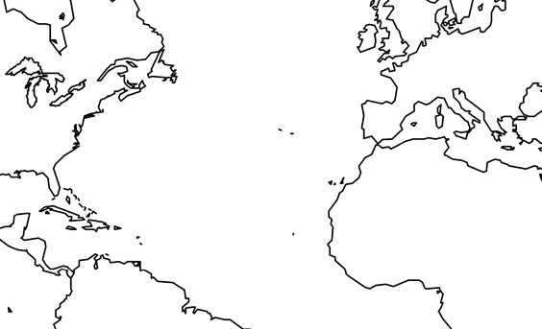

Plants diffused to the Americas:

Choose 2 plants you think are particularly important that were traded from Afro-Eurasia and 2 plants from the Americas and list the ways those plants are used.
Americas to Afro-Eurasia |  | Afro-Eurasia to Americas
Plant: | Plant: | Plant: | Plant:
How it’s used | How it’s used | How it’s used | How it’s used

Who do you think benefitted more from the exchange of plants? Why?

Animals and Diseases
Animals diffused to Afro-Eurasia:

Diseases diffused to Afro-Eurasia

Animals diffused to the Americas:

Diseases diffused to the Americas:

How helpful are the animals traded from the Americas to Afro-Eurasia? | How helpful are the animals traded from Afro-Eurasia to the Americas?

[think back to Guns, Germs, Steel] Why are there so many more deadly diseases in Afro-Eurasia than the Americas?

Conclusion
Was the Columbian Exchange good for the Americas? Why? | Was the Columbian Exchange good for Afro-Eurasia? Why?
The human eye can see more shades of green than any other color

