Countries to Know Name:
You will eventually be responsible for knowing the location of all these countries.
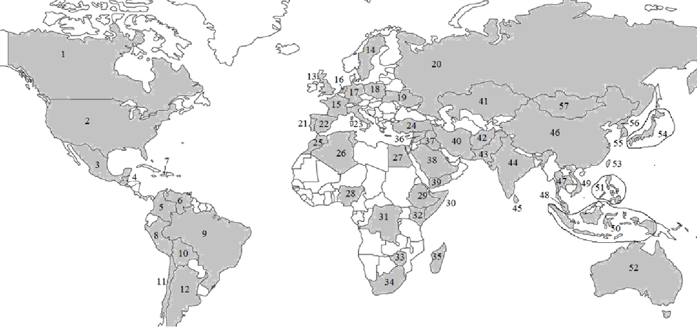
Label the following countries on the map on the other side of this paper.
Afghanistan | China | Haiti | Kenya | Pakistan | South Africa | Turkey
Algeria | Colombia | India | Madagascar | Peru | South Korea | Ukraine
Argentina | Democratic Republic of the Congo (DRC) | Indonesia | Malaysia | Philippines | Spain | United Kingdom
Australia | Egypt | Iran | Mexico | Poland | Sri Lanka | USA! USA!
Bolivia | Ethiopia | Iraq | Mongolia | Portugal | Sweden | Venezuela
Brazil | France | Italy | Morocco | Russia | Syria | Vietnam
Canada | Germany | Japan | Netherlands | Saudi Arabia | Taiwan | Yemen
Chile | Guatemala | Kazakhstan | Nigeria | Somalia | Thailand | Zimbabwe
 |  |  | North Korea

Practicing
Here are some options to practice this list:
- Fold down the key on the front side so that you can look at the map without seeing it. Try to name them in order. You can glance at the right answers when you need.
- Go to https://online.seterra.com/en/vgp/3185?c=UVDSP there you will find an interactive map quiz with all of these on it (except Mongolia).

