Income Inequality Name:
You will make four charts representing potential ways that America’s income might be distributed. Follow directions from Mr Best OR from powerpoint found on website.

Equal Distribution
Make a chart for if all income was distributed equally in America.
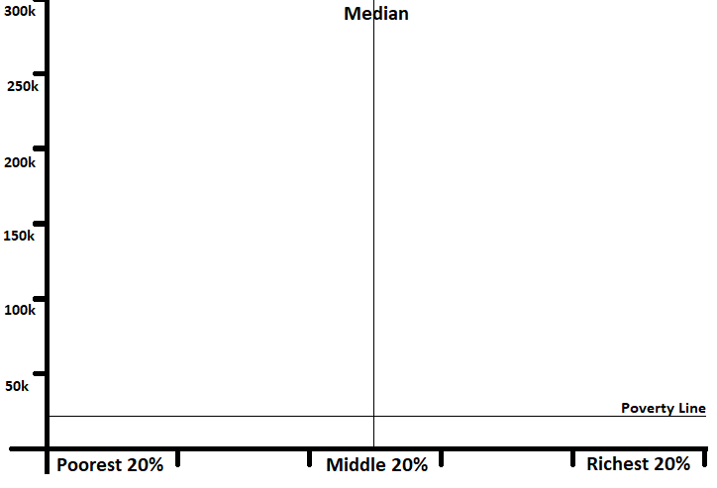

Ideal Distribution
Make a chart for what you think would be the IDEAL distribution in America

Perceived Distribution
Make a chart for how you THINK income is distributed. (don’t look it up)

Actual Distribution
Make a chart for how income is actually distributed.
Do you think this is okay? Why/why not?

