Mongol Conquest Sources CLASS SET
Source 1
In the spring of 618/1221, the people of Nishapur (a city in Persia) saw that the matter was serious ...

By the Saturday night all the walls were covered with Mongols... The Mongols now descended from the walls and began to slay and plunder.... They then drove all the survivors, men and women, out onto the plain; and ... it was commanded that the town should be laid waste in such a manner that the site could be ploughed upon; and that ... not even cats and dogs should be left alive.... They severed the heads of the slain from their bodies and heaped them up in piles, keeping those of the men separate from those of the women and children.

-Source: Ata-Malik Juvaini, Genghis Khan: The History of the World Conqueror, edited by UNESCO and Manchester University Press,

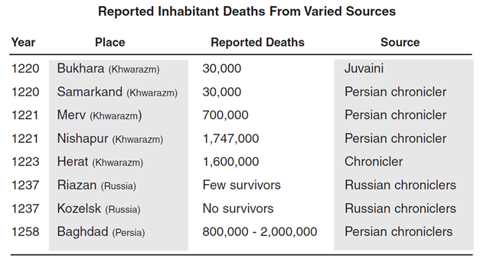Source 2

Note: these casualty figures are found in George Marshall’s Storm from the East. Despite very probably exaggeration, there is agreement among chroniclers of the time and historians of today that the number of deaths at Nishapur was staggering

Source 3
O people, know that you have committed great sins, and that the great ones among you have committed these sins. If you ask me what proof I have for these words, I say it is because I am the punishment of God. If you had not committed great sins, God would not have sent a punishment like me upon you.
-Genghis Khan, speaking to Muslim population of Bukhara after conquering it

From the King of Kings of the East and West, the Great Khan. To Qutuz the Mamluk, who fled to escape our swords.
You should think of what happened to other countries and submit to us. You have heard how we have conquered a vast empire and have purified the earth of the disorders that tainted it. We have conquered vast areas, massacring all the people. You cannot escape from the terror of our armies. Where can you flee? What road will you use to escape us? Our horses are swift, our arrows sharp, our swords like thunderbolts, our hearts as hard as the mountains, our soldiers as numerous as the sand. Fortresses will not detain us, nor armies stop us. Your prayers to God will not avail against us. We are not moved by tears nor touched by lamentations. Only those who beg our protection will be safe.
Hasten your reply before the fire of war is kindled. Resist and you will suffer the most terrible catastrophes. We will shatter your mosques and reveal the weakness of your God and then will kill your children and your old men together in the streets. At present you are the only enemy against whom we have to march.
-Hulagu Khan’s Ultimatum to Qutuz, Sultan of Mamluk Egypt

Source 4
The evidence of the chroniclers and travelers enables us to identify the striking changes wrought on Mongol morality by Genghis Khan’s legislation. Juvaini comments that Genghis Khan rooted out...adultery and theft. “War, strife, bodily harm or murder do not exist, robbers and thieves on a grand scale are not to be found among them,” remarks Plano Carpini, “and for this reason their houses and the carts in which they store their wealth have neither locks nor bolts.” Juzjani writes that no one except the owner would dare pick up even a whip lying on the ground. Ibn Battuta, describing how during travels in Iraq two horses went astray during the night, reports that although the travelers left the country soon afterwards the horses were brought to them on their journey twenty days later. He also comments that although there were many pack animals in the Kipchak area, these could be left unattended because of the severity of (Mongol) laws against theft.

-Source: Paul Ratchnevsky, Genghis Khan: His Life and Legacy, translated by Thomas Nivison Haining, 1991.

Source 5  The man in whose possession a stolen horse is found must return it to its owner and add nine horses of the same kind: if he is unable to pay this fine, his children must be taken instead of the horses, and if he have no children, he himself shall be slaughtered like a sheep.  -Laws of Genghis Khan  [Genghis Khan] ordered that all religions were to be respected and that no preference was to be shown to any of them.  -al-Makrizi  Whosoever commits adultery will be executed, whether or not they have previous convictions.  -Laws of Genghis Khan | If a woman who is captured by a Mongol has a husband no one will enter into a relationship with her. If [a Mongol] desires a married woman he will kill the husband and then have relations with the woman.  -Laws of Genghis Khan  Forbidden, under death penalty, to pillage the enemy before the general commanding gives permission; but after this permission is given the soldier must have the same opportunity as the officer, and must be allowed to keep what he has carried off, provided he has paid his share to the receiver for the emperor.  - Laws of Genghis Khan

