Mongol Conquest Sources ER CLASS SET
Source 1
In the spring of 1221, the people of Nishapur (a city in Persia) saw that the matter was serious ...

The Mongols then drove all the survivors, men and women, out onto the plain; and ... it was commanded that the town should be laid waste in such a manner that the site could be ploughed upon; and that ... not even cats and dogs should be left alive.... They severed the heads of the slain from their bodies and heaped them up in piles, keeping those of the men separate from those of the women and children.

-Source: Ata-Malik Juvaini

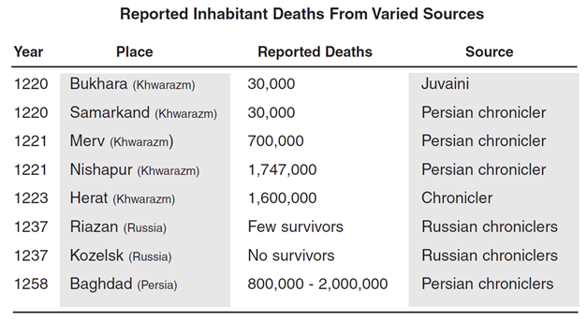Source 2

Note: these casualty figures are probably exaggerated.

Source 3
From the King of Kings of the East and West, the Great Khan. To Qutuz the Mamluk, who fled to escape our swords.
You should think of what happened to other countries and submit to us. You have heard how we have conquered a vast empire and have purified the earth of the disorders that tainted it. We have conquered vast areas, massacring all the people…
Hasten your reply before the fire of war is kindled. Resist and you will suffer the most terrible catastrophes. We will shatter your mosques and reveal the weakness of your God and then will kill your children and your old men together in the streets. At present you are the only enemy against whom we have to march.
-Hulagu Khan’s Ultimatum to Qutuz, Sultan of Mamluk Egypt

Source 4
“War, strife, bodily harm or murder do not exist, robbers and thieves on a grand scale are not to be found among the Mongols,” remarks Plano Carpini, “and for this reason their houses and the carts in which they store their wealth have neither locks nor bolts.”

Juzjani writes that no one except the owner would dare pick up even a whip lying on the ground. Ibn Battuta comments that although there were many pack animals in the Kipchak area, these could be left unattended because of the severity of (Mongol) laws against theft.
-Source: Paul Ratchnevsky, Genghis Khan: His Life and Legacy, translated by Thomas Nivison Haining, 1991.

Source 5  The man in whose possession a stolen horse is found must return it to its owner and add nine horses of the same kind: if he is unable to pay this fine, his children must be taken instead of the horses, and if he have no children, he himself shall be slaughtered like a sheep.  -Laws of Genghis Khan  [Genghis Khan] ordered that all religions were to be respected and that no preference was to be shown to any of them.  -al-Makrizi  Whosoever commits adultery will be executed, whether or not they have previous convictions.  -Laws of Genghis Khan | If a woman who is captured by a Mongol has a husband no one will enter into a relationship with her. If [a Mongol] desires a married woman he will kill the husband and then have relations with the woman.  -Laws of Genghis Khan

