Is China Still an Empire? Name:
You are going to investigate the Question of whether China is still an empire. To do so, you will use Mr Best’s Website to find several resources to compare the question.

Method Statement
Method  Statement | A state is an empire if…

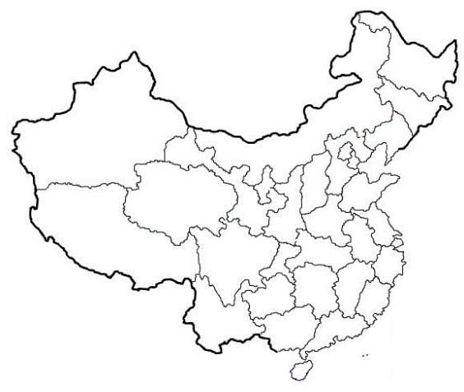
Chinese Ethnic Map
For the map on the right, choose a color or shading pattern for the following percentages of Han Chinese Residents:

Percentage Han Chinese | Color
95%+
90-95%
80-90%
60-80%
40-60%
Under 10%

Use the map on Mr. Best’s website to find out this information.

Ethnic Groups of Present Day China
How much of China is composed of people who are not Han Chinese?

Below, fill in a chart of the 9 most populous ethnic groups and leave the remaining percentage in the “Other” box. Use the chart on Mr Best’s website.

Ethnic Group | % Population | Total Number |  | Ethnic Group | % Population | Total Number
1. |  |  |  | 6.
2. |  |  |  | 7.
3. |  |  |  | 8.
4. |  |  |  | 9.
5. |  |  |  | Other

Is the number of people in China who do not consider themselves Han Chinese significant enough to count as “Controlling other nations?” Why?

Thesis and Support
Prompt: Is China Still an Empire?

Method
Statement
(copy from front page)

Claim  (pick one) | - China is still an empire  - China is no longer an empire
Reason | Because…

Support
Oh hey ther!

