Useful Organisms Name:
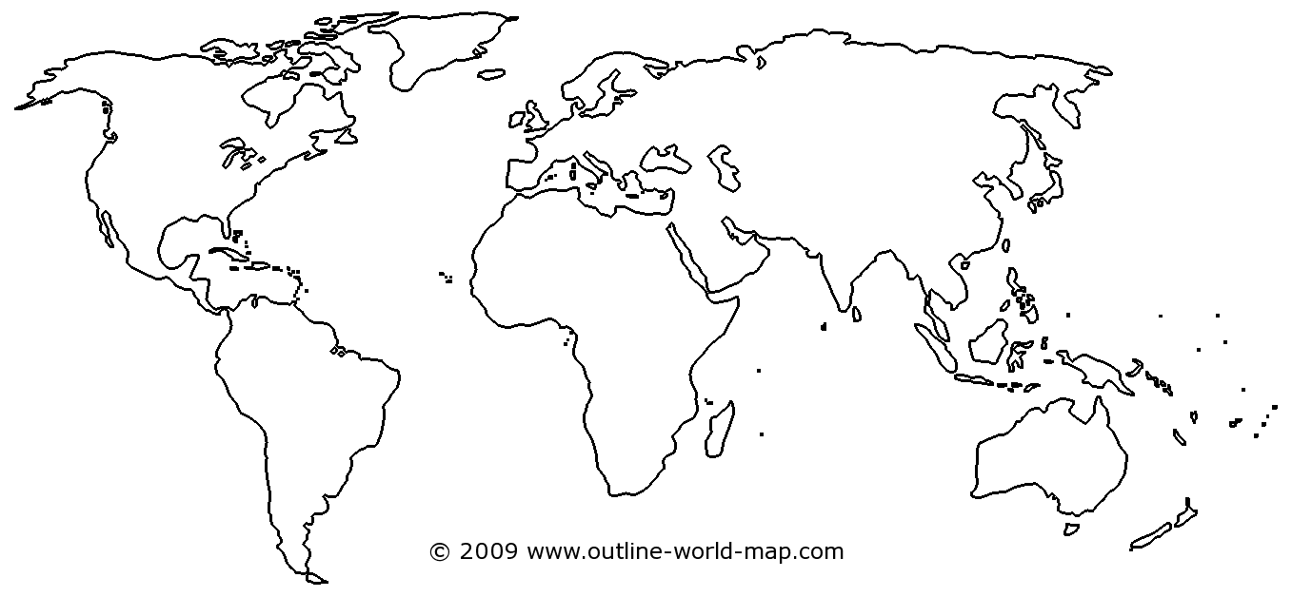
Fill out the map above with the following areas and label them with both their names and dates when agriculture began there:

- Northern Andes Mountains (South America)
- Mississippi River Valley (North America
- Central Mexico (Central America)
- Fertile Crescent (Middle East)
- West Africa
- Eastern China (East Asia)
- Papua New Guinea Highlands

Useful Organisms
Fill out each of the following charts with the useful domesticated animals and useful domesticated plants found in each area. Resources for this task are on Mr. Best’s website under “Useful Organisms”

Give each animal a letter after it for any of the following purposes they serve: (M) Meat, (W) Work, (T) Transportation, (F) Food, (C) Clothes, (S) Security/Warfare

Give each plant a check mark if it is a Cereal Grain.

Fertile Crescent Started Farming: 9,000 BC
Useful Animals | Useful Plants

Eastern China Started Farming:
Useful Animals | Useful Plants

Papua New Guinea Highlands Started Farming:
Useful Animals | Useful Plants

Central Mexico Started Farming:
Useful Animals | Useful Plants

North Andes Mountains Started Farming:
Useful Animals | Useful Plants

West Africa Started Farming:
Useful Animals | Useful Plants

Mississippi River Valley Started Farming:
Useful Animals | Useful Plants

